Ridge Regression

Part 2 Mathematical Formulation & Code from scratch
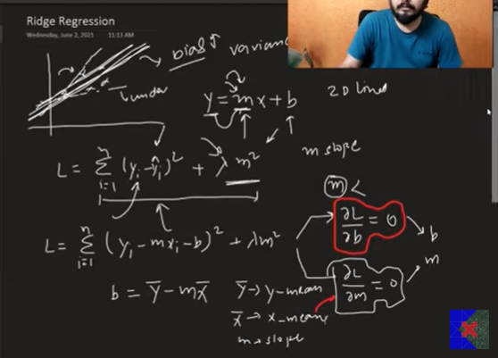
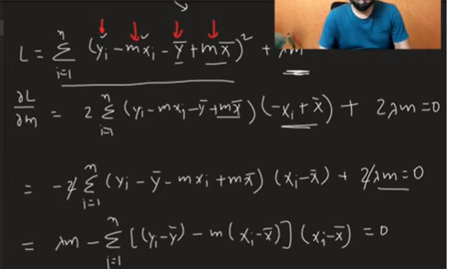
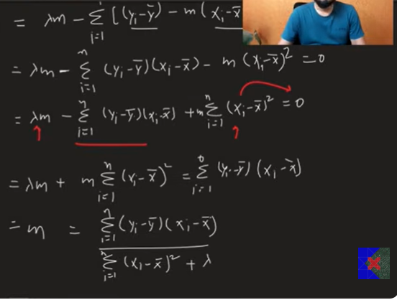
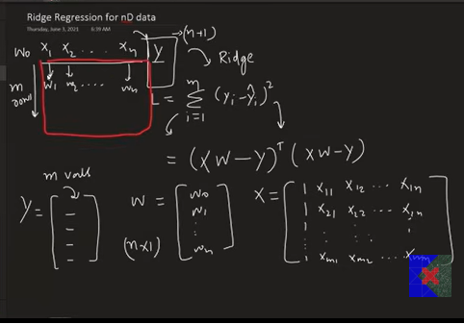
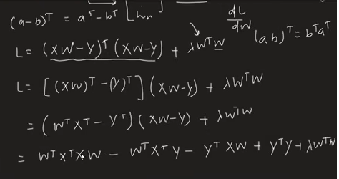
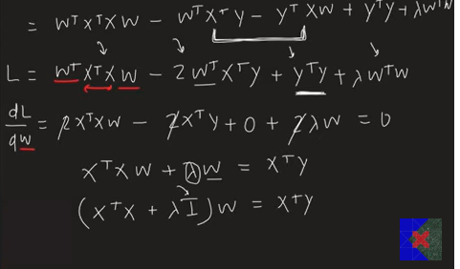

What is Ridge Regression?
Ridge Regression is a regularization technique used in linear regression to reduce overfitting.
Instead of minimizing only the Mean Squared Error (MSE), Ridge Regression adds a penalty term to the loss function.

Cost Function
For Simple Linear Regression,
[
J = \sum_{i=1}^{n}(y_i-\hat y_i)^2
]
For Ridge Regression,
[
J = \sum_{i=1}^{n}(y_i-\hat y_i)^2+\lambda m^2
]
For Multiple Linear Regression,
[
J=(XW-Y)^T(XW-Y)+\lambda W^TW
]
where
- (W) = weight (coefficient) vector
- (\lambda) = regularization parameter (hyperparameter)

Why Do We Need Ridge Regression?
Large coefficient values make the model highly dependent on input features.
This causes:
- Overfitting
- High variance
- Poor performance on unseen data
Ridge Regression reduces the magnitude of coefficients, making the model simpler and more generalizable.

Intuition
If the slope (coefficient) is
- Very large → Overfitting
- Very small → Underfitting
Ridge Regression tries to find a balanced value by penalizing large coefficients.

Ridge Regression in Simple Linear Regression
Normal Linear Regression
Slope:
[
m=\frac{\sum (x_i-\bar x)(y_i-\bar y)}
{\sum(x_i-\bar x)^2}
]
Intercept:
[
b=\bar y-m\bar x
]

Ridge Regression Slope
[
m=
\frac{\sum (x_i-\bar x)(y_i-\bar y)}
{\sum(x_i-\bar x)^2+\lambda}
]
Notice the only difference:
The denominator has an additional +(\lambda) term.

Intercept
[
b=\bar y-m\bar x
]
Since the slope changes, the intercept also changes automatically.

Effect of Lambda (λ)

λ = 0
Same as Linear Regression
No regularization.

Small λ
Slight reduction in coefficients.
Slightly better generalization.

Large λ
- Coefficients become very small.
- Model becomes simpler.
- Can lead to underfitting.

Visual Effect
Without Regularization
- Steeper regression line
- Fits training data closely
With Ridge Regression
- Flatter regression line
- Better generalization
Increasing λ continuously decreases the slope.

Ridge Regression Formula (Multiple Linear Regression)
Normal Equation:
[
W=(X^TX)^{-1}X^TY
]
Ridge Regression:
[
W=(X^TX+\lambda I)^{-1}X^TY
]
where
- (I) = Identity Matrix
The extra term (\lambda I) shrinks all coefficients.

Why Identity Matrix?
The identity matrix ensures that λ is added only to the diagonal elements of (X^TX).
In practice (e.g., scikit-learn), the first diagonal element corresponding to the intercept is often set to 0, so the intercept is not regularized.

Python Example (Using Scikit-learn)
from sklearn.linear_model import Ridge

ridge = Ridge(alpha=10)

ridge.fit(X_train, y_train)

print(ridge.coef_)
print(ridge.intercept_)

y_pred = ridge.predict(X_test)

Building Ridge Regression from Scratch

Step 1
Add a column of ones to the feature matrix.
X = np.insert(X, 0, 1, axis=1)

Step 2
Create the identity matrix.
I = np.identity(X.shape[1])
Do not regularize the intercept:
I[0][0] = 0

Step 3
Compute weights.
W = np.linalg.inv(
X.T @ X + alpha * I
) @ X.T @ y

Step 4
Separate intercept and coefficients.
intercept = W[0]

coef = W[1:]

Step 5
Prediction
y_pred = X @ W

Advantages
- Reduces overfitting.
- Handles multicollinearity.
- Improves generalization.
- Keeps all features.
- Stable model.

Disadvantages
- Introduces some bias.
- Does not perform feature selection.
- Large λ may cause underfitting.
- Hyperparameter tuning is required.

Ridge vs Linear Regression
Linear Regression | Ridge Regression
No regularization | Uses L2 regularization
Coefficients can become very large | Shrinks coefficients
Higher risk of overfitting | Better generalization
λ = 0 | λ > 0
Minimizes only MSE | Minimizes MSE + L2 penalty

Important Interview/Exam Points
- Ridge Regression uses L2 Regularization.
- It reduces coefficient values but does not make them exactly zero.
- It is mainly used to reduce overfitting.
- Increasing λ decreases the coefficient values.
- When λ = 0, Ridge Regression becomes ordinary Linear Regression.
- In the normal equation, Ridge adds (\lambda I).
- The intercept is generally not regularized (I[0][0] = 0 in implementations).
These notes cover the mathematical derivation, intuition, implementation, and practical usage of Ridge Regression in a concise, exam-oriented format.

